PROTOCOL FOR HANDLING DOGS FOR INTERNATIONAL ADOPTIONS
(Including lost dog protocol)

Sending your dog/ puppy overseas?

- Checking temperament of the dog.
- Crate Training your dog
- Paperwork required in India for import certification
- Introduction of your dog and flight volunteer?
- Preparing for your dog’s safety in USA/Canada/Europe.
- Crate and preparation in India.
- What to expect at the airport?
- Checking on the animal at stopover and in flight.
- Receiving the animal overseas.
- Protocol for safety overseas.
- Returning the equipment for use by others.

- Checking the temperament of the dog.
Most adopters/ rescues overseas will want a dog that is
- Friendly to adults - Have a stranger approach a dog in a neutral location (unfamiliar to the dog) and check how reactive the dog is to the stranger. A dog that ignores the stranger or is friendly towards the stranger is preferred. Please be very honest in judging temperament of the dog (this is for the long-term success of the dog in the new family plus for its safety).
- Friendly to other dogs (and cats) -Human or pet aggressive dogs are not OK to send overseas. Videotape your dog in a neutral zone (not at home or its territory). Introduce the animals to each other in a neutral zone and bring the new dog home to see how your dog reacts to it. Fearful, timid or extremely nervous dogs often fear bite people or other animals. Please be very through and honest in assessing their temperament.
- Document the evidence and share with the potential adopter or rescue. Also check the policy of the rescue regarding first right of refusal (incase pet needs to be returned for behavior issues the rescuer or rescue should have the first right of refusal before the pet is given up to an unknown shelter). This clause should be in the adoption agreement (of adopter or rescue).
- In the case of special needs dogs/cats pls document the handicap and the special needs. It is important to let the rescuer or adopter know if the animal
- Has control over their bladder or needs to be expressed by hand.
- Need to wear a diaper (are incontinent).
- Need help walking/moving/directing.
- All medical records pertaining to injury or illness.
- Crate Training your Dog/Cat
Most animals get extremely stressed when they are put in a crate for extended hours if
they are not used to it. To familiarize your animal with the crate please follow-
- Introduce the crate to the animal by assembling the crate and leaving the crate door open with the pet bedding inside the crate. Let the animal get used to the crate. DONOT put the animal in the crate. Let it discover the crate and not be afraid of it.
- If the animal doesn’t go inside the crate, then after the first day of leaving crate open drop some treat or the animals food bowl in side the crate. Most animals like a closed safe space and will go in on their own. Leave the door open and let the animal freely come inside and out of the crate.
- Once the animal is comfortable being inside the crate, only then should you close the door of the crate for short intervals. This will take the fear away and will also help animal realize that they shouldn’t poop and pee inside the crate.
- Once this procedure is followed and your animal can stay in the crate overnight, then the animal is ready for its international flight.

- Paperwork required in India for Certification
The following paperwork is required by your pet to fly internationally
- A health certificate issued not longer than one week before the flight date by a certified Vet.
- A microchip inserted in the animal and number or microchip mentioned on the health certificate. This microchip along-with the export certificate are the key to re-entry of that animal into India.
- Health card of the animal clearing showing
-Name
-DOB
-Colour
-Breed (most Indie dogs are classified as Whippet Retriever)
-Anti Rabies Shots (with sticker) to be given 30 days before flight date.
-DHPP-I shots with stickers and dates
-Microchip number
-Deworming History
d) The above paperwork can be submitted for an import/export certificate from Quarantine facility at Kapashera in Delhi (or local office). They will inspect the animal and issue a
certificate. Alternately service companies like Petfly can be used to get this certification

- The Flight Volunteer
The human flying with your pet is the flight volunteer. They will need to submit their Visa status (passport copy and Itinerary to obtain the export certification in Delhi.
This person will also be the person who will handle your pet in Delhi and Overseas. The following is crucial.
-The flight volunteer should be familiar with your animal. The animal should be comfortable with the flight volunteer. It is imperative that the flight volunteer meets the animal at least 3 times before they fly. Handing over an animal to a strange person is not acceptable. Animals are very stressed during the flights and can escape/ get injured.
-The person should have the ability to handle your animal. If at any point you are not comfortable with the person ability you should STOP and not allow your dog to fly. If your gut is telling you some thing, PLEASE LISTEN TO IT.
-It takes the flight volunteer an extra hour in Delhi for documentation to take the animal on board. Agent companies like Petfly can assist with this process. Ensure that the flight volunteer is aware of the pet’s latest health, fears, issues and has the emergency contact information readily available.
- Preparing for your dog’s safety in India and Overseas.
The following items are needed to ensure your dogs safety
- Follow the 2 door protocol. Animals are scared in unfamiliar situations and will tend to run away if they escape. To assure this doesn’t happen there should always be 2 doors between your pet and the open road if they are in an unfamiliar circumstance. This means while they are being transported in a vehicle the must be in a crate and not open. In extraneous circumstances if they must be left open in a car they should be restrained with their harness to the seat belt.
- They should be put inside a vehicle in an area which is completely enclosed. If they are on a harness and being walked to the vehicle outside the 2-point harness should be used (as explained). Also after leaving EVERY animal in the car in case of multiple animals, the door must be LOCKED and the automatic windows and doors should be DISABLED from the driver’s door. Take a minute to understand the controls of a vehicle if you are unfamiliar with it.
- A dog can get out of the collar and can chew off the shoulder harness so you must use BOTH. The shoulder harness and collar need to be removed before animal flies as it is a choking hazard. Upon receiving the dog they have to be put back on
2-point harness for dogs for added safety
The following harnesses are available FOR LOAN at Dr Choudhry’s pet clinic in Anand Niketan. We will be glad to loan them to you but you must return them to us as they are expensive and we hope to keep helping multiple animals with the same. In case of damage or loss of these harnesses, you will need to replace them.
-The EZ harness (Loan cost 0- replacement cost 35 USD) <For easy handling>
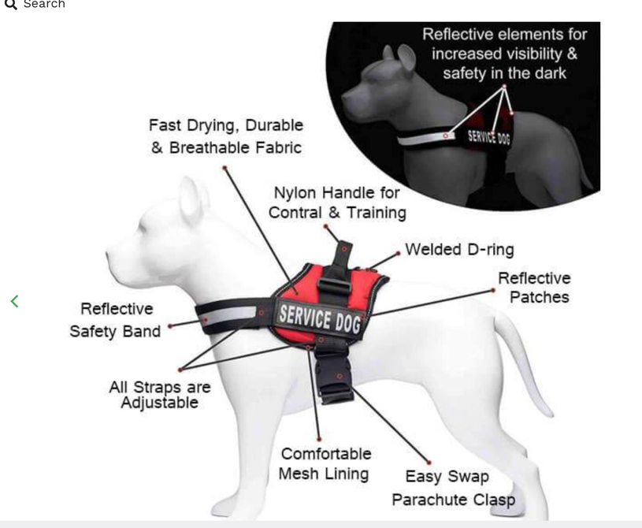
Slip on head and snap around chest. Put on in 2 seconds
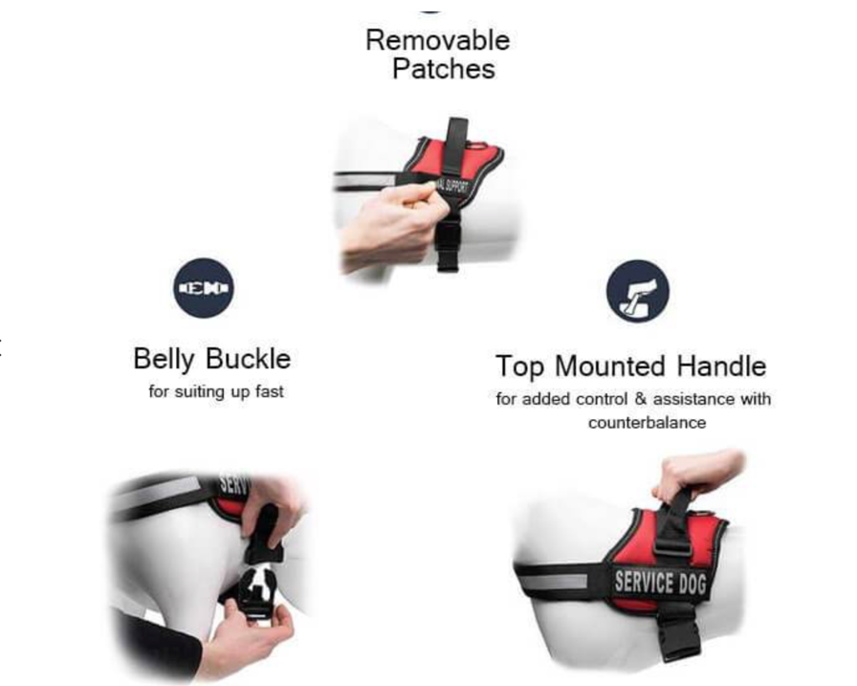

-The Easy Sport (Loan cost 0- replacement cost 25 USD) <For seat belts>
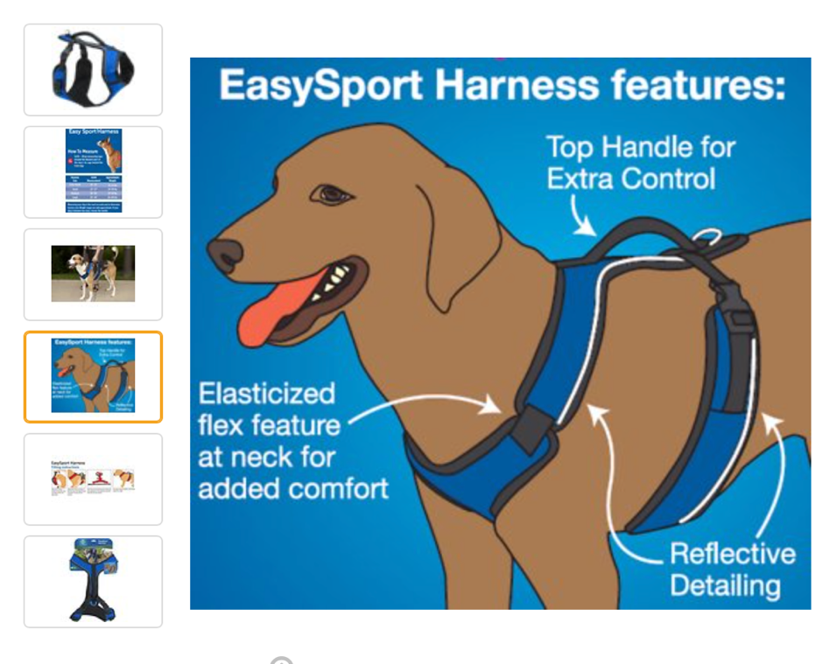
Easy handling and putting seat belt through the top loop
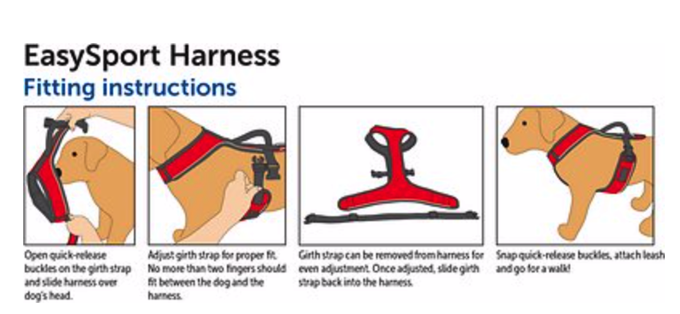

-The No-pull Harness (Loan cost 0- replacement cost 25 USD) <For dogs who pull>
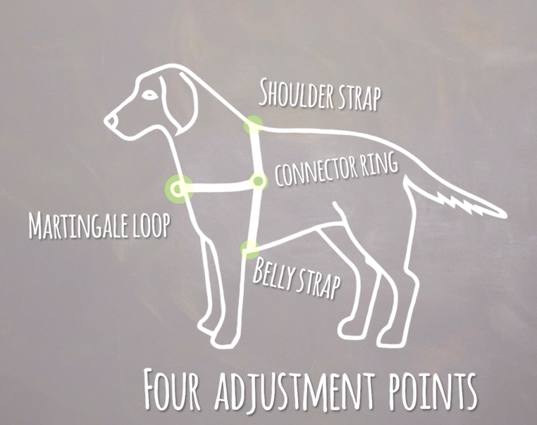
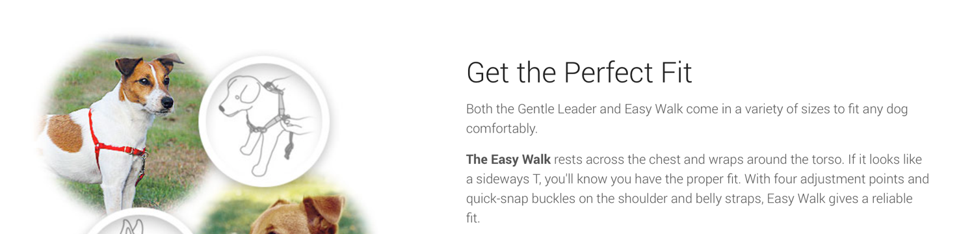
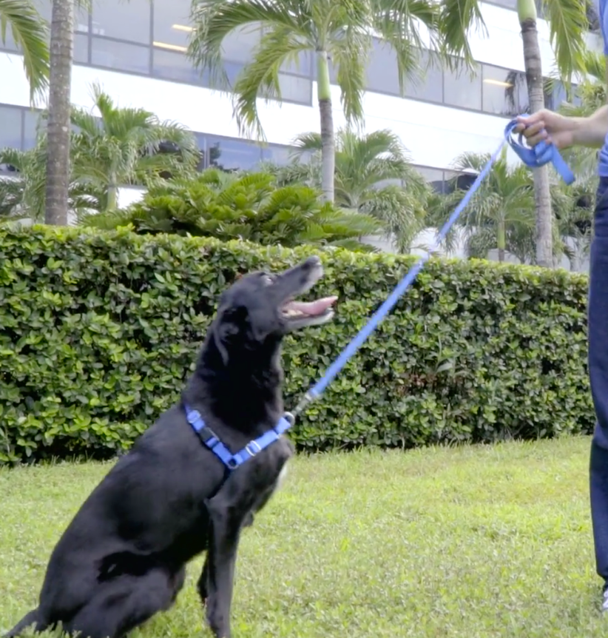

PLEASE MAKE SURE YOU ADJUST AND FIT YOUR HARNESS TO YOUR DOGS SIZE BEFORE YOU HAND THEM OVER TO THE VOLUNTEER AND THAT THE VOLUNTEER KNOWS HOW TO USE

- GPS tracking devices are available for loan from Dr Choudhry’s office. These devices are expensive and need to be returned after your trip or replaced if lost/damaged. This will enable us to help more animals like yours.
-The Whistle 3 GPS tracker (Loan cost 0- replacement cost 80 USD) + Subscription
<Unlimited range>
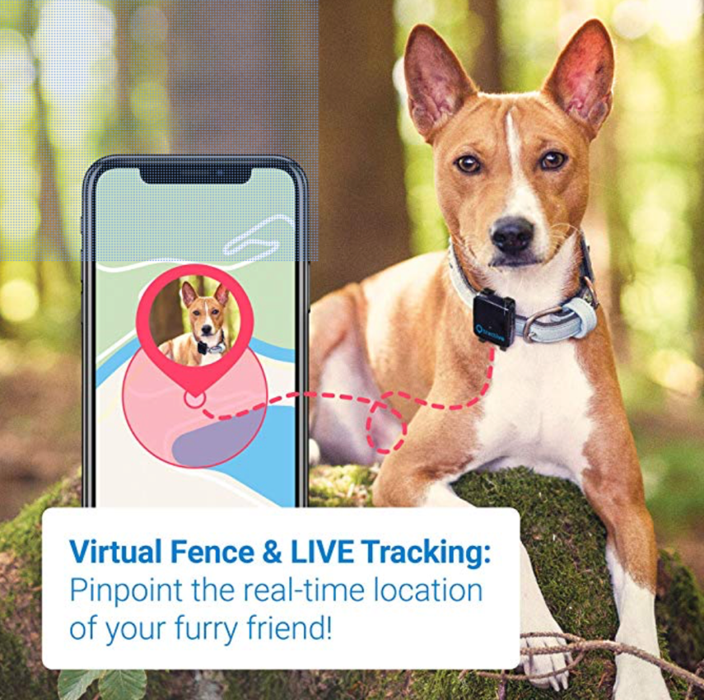
-The Pet GPS tracker (Loan cost 0- replacement cost 20 USD)
No subscription. Range, (30 to 50 meters)
For subscriptions contact these people.
Name | Contact | Location
Inder Sandhu | +91-9815135936 | Chandigarh, India
Jessica Haltzman | +1 (215) 692-2370 | Seattle, USA
XXXXX
XXXXX

- Crate and its preparation in India
The crate your animal travels in must be
-AITA approved.
-Must have 4 fingers between top of crate and the animals head while standing. Animal should be able to turn around and sit down in crate.
-It should have all the fasteners secured and tab locked.
-Should have a pee-pad at the bottom when you go to airport.
-Must had pouches of food taped to the top of the crate.
-Must have a drip water bottle that you can fill with ice before you hand the animal over
-The flight volunteer must ensure that zip ties are used by airline to secure crate door.
-Collars and leashes should be removed from crate as they are choking hazards.
-Toys and blankets are acceptable in crates but they will most likely get soiled.
DOGS SHOULD NOT BE PUT INSIDE CRATES AT PARKING LOT/TERMINAL IN DELHI. SEVERAL DOGS HAVE ESCAPED AND RUN AWAY. PLS BRING ANIMALS INSIDE THE CRATES AT AIRPORT.
- What to expect at airport at Delhi.
- All animals have to be booked on flights previously.
- Airline will check in your animal after verifying weight of animal.
-You will be charged for oversized baggage (most airlines ask for money in advance)
-Crates will be inspected in oversize baggage X-ray. Flight Volunteer will take the animal out of crate and then put them back in after X-rays are done.
8. Checking on Animals in Transit.
You can request the airline staff to ensure your animals have boarded. You can also ask the flight attendants to check if the animals are OK. The are not obliged to check but most of them do.
9. Receiving the Animal overseas
When you receive the animal overseas you should have the health certificate and the import certificate ready. If you are transporting 3 or lesser animals, you (or flight volunteer) can claim them as their own pets. In that case import permit is not required.
Some airports ask to go through a broker for import purposes. This is not a requisite step yet but some airports are enforcing it. Please contact authorities to ensure you are prepared for all questions.
You will receive the animals in oversize baggage and go through the Deptt of Agriculture, red channel and declare them. Upon checking documents, you will be let go out the airport with your animals.
10. Protocol for safety overseas.
Make sure you have adequate volunteers to help you with the transport of animals. A lot of animals have been lost at the airport due to carelessness of the flight volunteers.
To avoid any mishaps.
-Follow the 2 door policy at all times.
-Take the animals out of their crate only once they are at a secured location at somebody’s home or in a shelter.
-immediately put the harness and GPS tracker on the animal.
-If you must put the animal in a transport vehicle without their crate, use the easy sport harness to tie them to the seat belt. Lock the door each time and disable the automatic door and windows.
-If the animal goes missing please follow the ‘missing dog’ protocol attached to this doc
-Register the microchip and activate the GPS tracker as soon as you reach. Keep charged
11. Returning the Borrowed Equipment
Please realize that the equipment we will lend out is expensive and not easily replaceable. If you were to lose/damage any equipment we would recommend you replace it during your trip. At the end of your trip please return the equipment in a clean and good state to Dr Choudhry. We do not charge any money for it but we will consider taking a deposit for the same.

LOST DOG PROTOCOLS – USA

THE FIRST HOURS ARE VITAL
- DO NOT CHASE YOUR DOG!! If you see the dog or if it has run out the door and hesitates you should sit or lie down and act injured – DO NOT call the dog or run after it and try to catch it. This is the #1 mistake that people make and causes the dog to run further away as they feel threatened.
- CONTACT THE ORGANIZATION THAT YOU ADOPTED YOUR DOG FROM IMMEDIATELY. THEY HAVE CLEAR STEPS TO FOLLOW IN THIS SITUATION AND ARE THERE TO HELP YOU.
- IF YOU CANNOT GET HOLD OF YOUR ORGANIZATION, CONTACT US DOG EMERGENCY VOLUNTEERS AT:
- Inder Sandhu +91 9815135936 inderpal.sandhu@hotmail.com
Jessica Haltzaman +1 (215) 692-2370 delhithestreetdog@gmail.com
- START A THOROUGH SEARCH IMMEDIATELY. SEARCH FOR AS LONG AS IT TAKES.
Missing dogs move in a circular or triangular pattern around the area where they went missing – pattern size increases as time passes.
Double bag a scent item straight away in case a tracker needs to be utilized. We recommend this be done as soon as possible, especially if your Dog is newly arrived or shy. Any tracker dog requires a scent or a very precise location where the lost dog has been seen. A scent is definitely more accurate than a location. Anything with the dog scent should be preserved so that the tracking dog has something to sniff. It could be a leash, a toy, a towel or dog bed etc.
Tend to hide around that area and not move too far during the first few days. As time goes on, the circular or triangular pattern tends to increase.
Leave some food out at home, and also at the site where your dog went missing, along with something that smells familiar (such as a blanket, your dog’s bedding or sweater).
Your dog may be drawn to the smell of the food - may encourage him/her to stay close by.
Have your charged cell phone with you at all times.
Bring a crinkly bag, flashlight/torch, lead and some tasty treats.
Make sure someone is at home at all times with access to a telephone, in case your dog turns up.
If lost dog has bonded with your other dogs, bring them along – the scent of animals can travel long distances and a familiar fellow pet could draw them out.
Not bonded with other dogs, do not bring along in the search party – could scare lost dog further away.
If your lost dog has been with you for some time, is bonded and comfortable with you, call out to them.
Do not call out to a recently arrived and/or shy dog – this could scare your dog further away.
- REACH OUT FOR HELP
It’s important that you don’t become exhausted. Assign a ‘leader’ to cover each important task - search, poster distribution, contacting local media, etc.
Have back up leaders who can share the responsibility and allow others to rest.
Teams to work in a shift pattern, to allow search to continue throughout the day and night
PREPARE A POSTER/FLYER RIGHT AWAY AND START DISTRIBUTION. TIME IS IMPORTANT!
The key to a successful poster is to KEEP IT SIMPLE AND MAKE IT HUGE.
Should include the words LOST DOG / MISSING, your contact details, and the words DO NOT APPROACH or DO NOT CHASE OR TRY TO CATCH. The main focus of the poster should be a photo of dog.
Posters must be large and colourful - laminate or cover poster in plastic to protect from rain.
Example of an effective poster
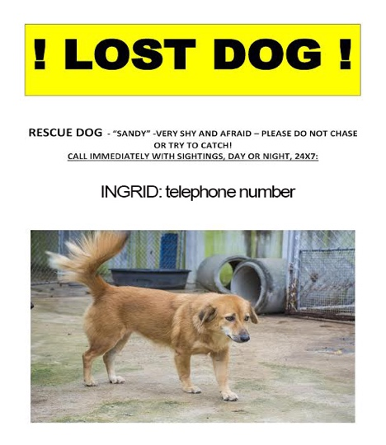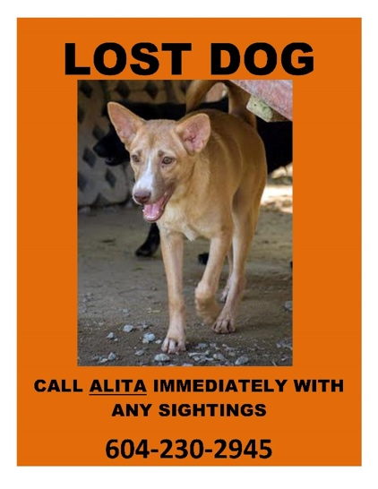
http://lostdogsofamerica.org/making-large-neon-signs-for-your-missing-dog-is-cheap-and-easy-heres-how/
POSTER/FLYER DISTRIBUTION
Blanket the local area heavily. THERE IS NO SUCH THING AS TOO MANY POSTERS. Poster/flyer campaigns are proven to be one of the most effective tools in finding a lost dog.
Put your posters up on every block/street – you could use telephone poles, mail boxes, etc. Post along jogging routes, in dog parks, walking trails, public park entrances and other places where pedestrians would gather.
Hand out in person wherever people are shopping.
Put under car windshield wipers.
Tape a poster/flyer inside your car’s rear window (but ensure it does not impede driver visibility).
Ask volunteers to stand with large posters in a safe area, where they are visible during peak traffic times (e.g. near traffic lights).
Go door to door and talk to people in the local area. Hand them a flyer and ask them to check their outbuildings.
Don’t be afraid to ask passers-by! Many times people will have seen a dog while out walking or collecting their mail. This can often provide crucial leads for lost dogs.
Use social media – Facebook is a great way to spread the word far and wide! In addition to your own timeline, post on pet searching Facebook pages. You can also access some helpful sites through the SPCA website. Some examples of effective social media sites are:
Pet Searchers
helpinglostpets.com
Craigs List
We also recommend you distribute your posters/flyers to the following:
Local dog rescue organisations.
SPCA
Vet clinics
Grooming parlours
Animal pounds
Pet stores
City halls
Police
Bus stations, train stations, taxi stations, etc
Bus drivers, taxi drivers, etc
Ambulance and fire service
Community centres, homeless centres
Radio and TV stations
Parks and recreation centres
Sports fields, golf courses and other public events venues
Banks, post offices, stores/shops
Schools and playgrounds
Dog walkers
Delivery businesses
SEARCHING
Everyone involved in the search should read the following:
www.missingpetpartnership.org/recovery-tips/lost-dog-behavior/
http://www.missingpetpartnership.org/recovery-tips/panicked-pets/
Ensure you have people (preferably people your dog knows) stationed at the last seen location, in the spot where your dog went missing and at home.
A lost dog is likely to be traumatised and terrified, and will probably go to ground out of fear, especially during the day when there is more traffic and people around. Lost dogs are often more active and mobile during the early morning and evening.
Dogs that are lost enter ‘survival mode’. They will often not come out of hiding, even for their beloved owner. When calling for a lost dog, try to use words that he/she is familiar with. You may be able to lure your dog out with strong smelling treats, such as fried chicken or hot dogs. Cooking meat on a small disposable bar-b-que in the area where the dog was last seen might lure him/her out of hiding.
Use a map and assign your teams to quadrants, so that you can cover each area thoroughly. Mark each sighting one the map with a pin, to help you establish a pattern and use it to estimate where your dog is most likely to appear and where he/she is sleeping. Grassy areas with trees for shelter and/or bodies of water are likely hiding places.
Important note: for newly arrived/shy/nervous dogs is it especially important that the search team are instructed to simply watch for sightings and report back to you. Too many people trying to actively chase down a lost dog will scare him/her further away.
PROFESSIONAL SEARCH AND RESCUE TRACKERS
If your dog is a newly arrived rescue/shy/nervous he or she might be wary of approaching people and might not come when called. You may need professional help from a search and rescue tracker service. They can make all the difference in getting your dog back. Time is of the essence, so contact them straight away.
The sooner the trackers can find your dog’s scent, the better. This can be crucial in many cases. Assign a team leader and a back-up person as the single point of contact for the trackers.
Search and rescue trackers often use hidden cameras, drones and live traps. Live traps need to be checked regularly – at least twice a day, and in areas where there are predators they must be monitored constantly. You may find other animals in your trap which should be released immediately with as little trauma as possible. It’s best to disguise the trap with branches, greenery etc.
If there are no search and rescue trackers in your area, local rescues may be able to help you. You may be able to borrow a live trap from a local rescue, SPCA or Animal Control.
HELPFUL LINKS
www.lostdogsofamerica.org/

www.3retrievers.com/guide-to-finding-lost-dogs

DON’T GIVE UP HOPE. MANY CASES WHERE PETS HAVE BEEN LOST FOR WEEKS, AND EVEN MONTHS, HAVE HAD HAPPY ENDINGS DUE TO THE STRENGTH AND DETERMINATION OF THE OWNER AND SEARCH TEAM.

RECOMMENDED VEHICLE FOR TRANSPORTATION
Company: U-Haul or Enterprise Rent-A-Car
Type: Cargo Van
Capacity: Can hold up to 4-6 kennels
